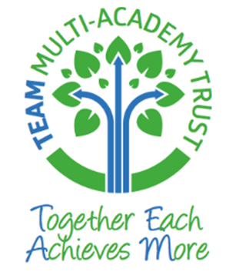

Umberleigh Academy
Homework Policy









Aims and Objectives

Within the TEAM academy trust we see homework as a significant facility to help children develop their basic skills and explore aspects of their learning. It is important that parents and carers see homework as an opportunity to support their child’s education and work in partnership with school. It should not become a chore!

Throughout the school day we expect our children to give their best and therefore core homework tasks should not take up an exceptional amount of time. Little and often is the best approach.

Children in the Foundation Stage and Key Stage One

At this age, homework is a time for parents/carers to informally talk to their child about school and listen to them read. For children to make good progress in reading they will need to be reading daily at home which can be recorded in their reading record books. Reading, at this stage, is a priority above any other home learning. Engaging your child in conversation is vital at this age group as it offers the most important building block for future learning; the termly curriculum newsletter and weekly newsletter will help provide some context and key topics to discuss.

Core Homework for Years Three, Four and Five

Homework will become more formalised for this age group, with (at most) 20 - 30 minutes set aside each evening to:

- Read and discuss their book either independently or with an adult - again, for children to make good progress in reading they will need to be reading daily at home which can be recorded in their reading record books.
- Complete spelling activities set by the school
- Use TT Rockstars to learn their multiplication facts

Core Homework for Year Six
Homework for Year 6 has an additional purpose in that it prepares pupils for the routine of secondary school. There is an expectation that the three bullet points listed above will continue and alongside each child will receive an additional task that is related to literacy or numeracy. This will be set on Friday of each week and will be handed to the class teacher on the following Wednesday.

Optional Homework Projects
For those children who would like to follow up their Big Event topic work at home, each class group will be set a choice of extended tasks each term. We will encourage the children to choose at least one task per half term to complete although there is no limit to this! This approach will give children the opportunity to lead their own learning and pursue interests within the chosen area of study. Children who take part in the project will be rewarded for their effort and their work will be shared with others.

Date of the next policy review: September 2023

.

