Musician of the Month
 | Musician: | Genre: | Facts: | Famous Pieces:
January | Hildegard  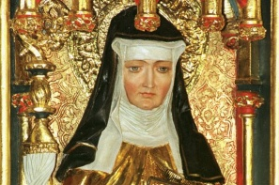 | Classical (Early) | 1098 – 1179 (Middle ages)  German  - One of the first identifiable composers in the history of Western music  - At age 8 she was sent to a monastery where she spent the next 40 years of her life  - Famous for her hymns & chants | - Ordo Virtutum  - A Feather on the Breath of God  - Heavenly Revelations
February | 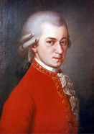  Mozart | Classical | 1756 – 1791  Austrian  - He is one of the most influential and popular classical musicians of all time  - He composed over 600 works for the orchestra, voice and piano | - Duettino- Sull'aria  - Eine Kleine Nachtmusik  - Rondo Alla Turca
March | 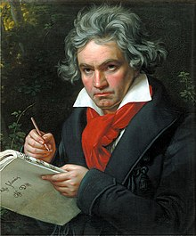  Beethoven | Classical | 1770 – 1827  German  - Widely regarded as the greatest composer who ever lived  - Composed 722 works for the orchestra and piano  - By the time he was 45 he was totally deaf, but continued to compose music | - Moonlight Sonata  - Fur Elise  - Symphony No. 5
April | 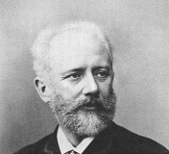  Tchaikovsky | Classical (Romantic) | 1840 - 1893  Russian  - He wrote some of the most popular classical music including 3 ballets (The Nutcracker, Swan Lake, Sleeping Beauty) | - “The Dance of the Sugar Plum Fairy” (Nutcracker )  - Swan Lake  - 1812 Overture
May | 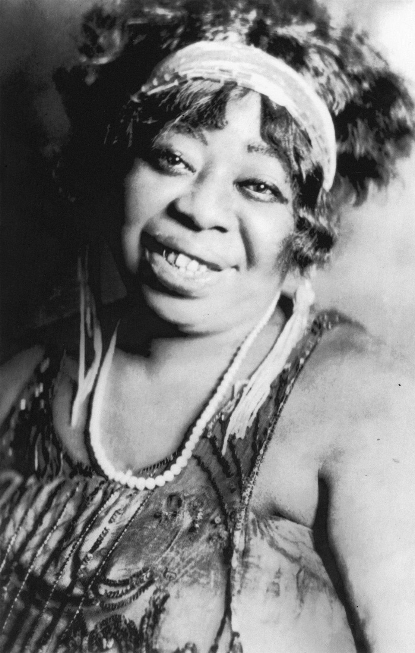  Ma Rainey | Blues | 1886 – 1939  American  - Known as “The Mother of Blues”  - One of the earliest recorded blues musicians  - She made almost 100 records | - Jealous Hearted Blues  - Moonshine Blues  - Soon This Morning
June | 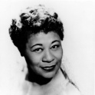  Ella Fitzgerald | Jazz | 1917 - 1996  American  - Referred to as the "First Lady of Song", "Queen of Jazz", and "Lady Ella"  - Famous for her ability to improvise; particularly in her scat singing (wordless improvisation) | - How High the Moon  - Dream a Little Dream of Me  - One Note Samba
July | The Beatles  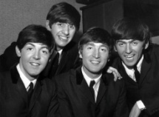 | Pop/Rock | 1960s – 1970s  British  - The best selling music act of all time  - They have the most number 1 hits of all time (20)  - The “Fab Four”: John Lennon, Paul McCartney, George Harrison, Ringo Starr | - Imagine  - Let it Be  - Hey Jude
August | Which musicians will you listen to over the summer?
September | 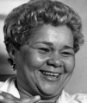  Etta James | Gospel/Soul | 1960s - 1980s  American  - Considered to be “one of the greatest voices of her century”; famous for her deep and earthy voice  - As well as a gospel and soul singer, she also performed jazz, rock n roll, R&B and blues | - This Little Light of Mine  - Oh Happy Day  - Swing Low Sweet Chariot
October | 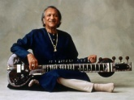  Ravi Shankar | Indian Classical Music | 1920 – 2012  Indian  - A sitar virtuoso (expert); he played and composed music for the sitar  - Composer and founder of the National Orchestra of India  - He continued to perform until the end of his life | - Three Ragas  - Theme to Panther Panchali  - Raga Palas Kafi
November | Ladysmith Black Mambazo  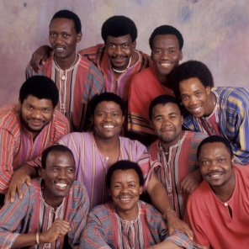 | South African A Cappella | 1960 – present  South African  - An all male group singing in the traditional style of the Zulu people  - The group are all relatives, mostly brothers and cousins  - Ladysmith = their home town.  - Black = the strongest of all farm animals, the black ox.  - Mambazo = the Zulu word for axe, a symbol of the group's vocal strength. | - Homeless  Inkanyezi Nezazi  - Hello my baby
December |   Fisherman’s Friends | British Folk | 1995 – present  British  - A folk music group from Port Isaac in Cornwall who sing sea shanties  - Often a cappella, sometimes with simple instrumentation  - The group consists of two brothers and their friends | - Keep Hauling  - John Kanaka  - The Leaving Shanty

