Dear Parents,
You may recall our CEO, Mr Thomas, writing a letter to you a couple of weeks ago explaining how the Department of Education introduced the compulsory teaching of Relationships and Health Education back in September 2020. He highlighted that due to the disruption of Covid-19 schools around the country have been given additional time to review their PSHE/RSE (Personal, social, health, economic/relationships and Sex education) curriculum to ensure the children receive a curriculum that ensures they are well prepared for the future.
As a forward-thinking Trust, we started our preparations for the new PSHE curriculum back in 2019 and as a result of this we have been developing the use of planning and resources provided by the PSHE Association. This resource provides a detailed and comprehensive scheme of learning which meets all the requirements of the Department of Education’s new Relationships, Sex and Health Education guidance.

The PSHE Association content covers all areas of PSHE and is organised to cover the following areas across the school year:

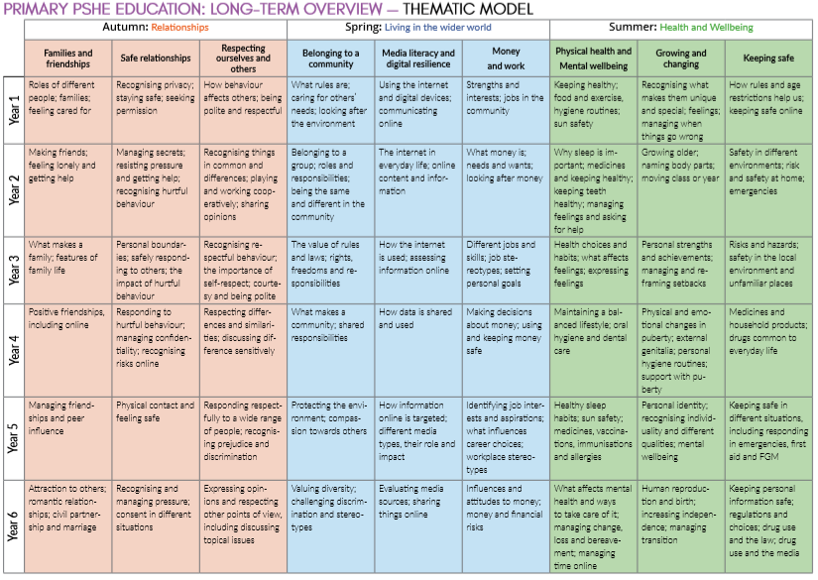
Growing and Changing
We want our children to learn to understand and respect our common humanity, diversity and differences so that they can go on to form the effective, fulfilling relationships that are an essential part of life and learning. The grid below shows specific RSE learning intentions for each year group in the ‘Growing and Changing’ units that will be taught during the Summer Term.

Growing and Changing
Year | Content Covered
1 | Recognising what makes us unique and special; feelings; managing when things go wrong  - to recognise what makes them special and unique including their likes, dislikes and what they are good at  - how to manage and whom to tell when finding things difficult, or when things go wrong  - how they are the same and different to others  - about different kinds of feelings  - how to recognise feelings in themselves and others  - how feelings can affect how people behave
2 | Growing older; naming body parts; moving class or year  - about the human life cycle and how people grow from young to old  - how our needs and bodies change as we grow up  - to identify and name the main parts of the body including external genitalia (e.g. vulva, vagina, penis, testicles)  - about change as people grow up, including new opportunities and responsibilities  - preparing to move to a new class and setting goals for next year
3 | Personal strengths and achievements; managing and reframing setbacks  - that everyone is an individual and has unique and valuable contributions to make  - to recognise how strengths and interests form part of a person’s identity  - how to identify their own personal strengths and interests and what they’re proud of (in school, out of school)  - to recognise common challenges to self -worth e.g. finding school work difficult, friendship issues  - basic strategies to manage and reframe setbacks e.g. asking for help, focusing on what they can learn from a setback, remembering what they are good at, trying again
4 | Physical and emotional changes in puberty; external genetalia, personal hygiene routines; support with puberty  - how to identify external genitalia and reproductive organs  - about the physical and emotional changes during puberty  - key facts about the menstrual cycle and menstrual wellbeing, erections and wet dreams  - strategies to manage the changes during puberty including menstruation  - the importance of personal hygiene routines during puberty including washing regularly and using deodorant  - how to discuss the challenges of puberty with a trusted adult  - how to get information, help and advice about puberty
5 | Personal identity; recognising individuality and different qualities, mental wellbeing  - about personal identity and what contributes to it, including race, sex, gender, family, faith, culture, hobbies, likes/dislikes  - that for some people their gender identity does not correspond with their biological sex  - how to recognise, respect and express their individuality and personal qualities  - ways to boost their mood and improve emotional wellbeing  - about the link between participating in interests, hobbies and community groups and mental wellbeing
6 | Human reproduction and birth; increasing independence; managing transition  - to recognise some of the changes as they grow up e.g. increasing independence  - about what being more independent might be like, including how it may feel  - about the transition to secondary school and how this may affect their feelings  - about how relationships may change as they grow up or move to secondary school  - practical strategies that can help to manage times of change and transition e.g. practising the bus route to secondary school  - identify the links between love, committed relationships and conception  - what sexual intercourse is, and how it can be one part of an intimate relationship between consenting adults  - how pregnancy occurs i.e. when a sperm meets an egg and the fertilised egg settles into the lining of the womb  - that pregnancy can be prevented with contraception  - about the responsibilities of being a parent or carer and how having a baby changes someone’s life

All lessons will be taught using simple, child-friendly language and pictures, which help children understand changes more effectively.
The key concepts that children learn in PSHE and RSE lessons are inner strength, self-esteem and resilience. These are really important as they help keep children safe and it helps them make healthy decisions later in life.
Withdrawal from RSE Lessons
Parents have the right to withdraw their children from all or part of the Relationships and Sex Education provided at school except for those parts included in statutory National Curriculum Science. Those parents wishing to exercise this right are invited in to see the head teacher and/or PSHE lead who will explore any concerns and discuss any impact that withdrawal may have on the child. Once a child has been withdrawn they cannot take part in the RSE programme until the request for withdrawal has been removed. Materials are available to parents/carers who wish to supplement the school RSE programme or who wish to deliver RSE to their children at home.

If you are considering withdrawing your child out of RSE lessons within PSHE, please consider the following:

• All the other children in your child’s class will have been taught this information and may well talk to your child about it, perhaps in the playground… and potentially mislead them or confuse them as a result. It may prove far better to allow experienced and sensitive teaching staff to teach your child in a progressive, developmental way that is grounded in research.

• They will be learning about reproduction in Science lessons. The RSE in PSHE will echo this and will concentrate on teaching children how to enjoy healthy, appropriate relationships, improve self-esteem and self-confidence, and make healthy, informed choices. When viewed this way, it is hoped that RSE won’t be seen as contentious or a cause for concern, but rather as helpful.

It is clear that the Covid-19 pandemic will have had an impact on the mental health and wellbeing of children across the country. Due to this, it is important to all of our staff that we continue to prioritise PSHE/RSE content based on the needs of pupils, with particular attention to the importance of positive relationships, as well as mental and physical health. We believe PSHE/RSE should be a partnership between the school and the parents/carers, working for every child’s safety and benefit. With this in mind we have placed our new policy on the website for you to look at. I am very eager to gather your feedback concerning the content and in order to do this I will be sending out a link to a questionnaire via email next week. Your views are very important to us here at Umberleigh Academy so if you can spare the time to complete the questionnaire it would be very much appreciated.

Best wishes,

Corrinne Smith

